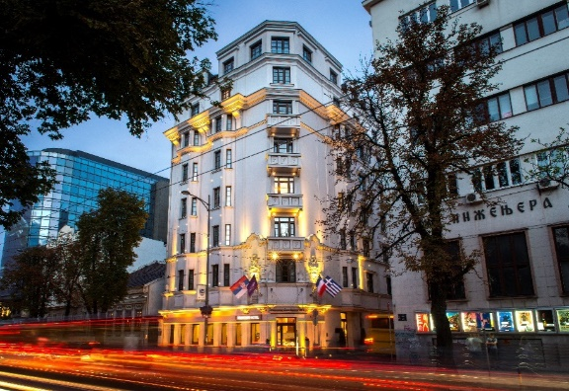

**Reservation Form for**

**ECER** **2025** **for the period 07-13 September 2025**

First Name: __________________________________ Last Name: ______________________________

**Room type with buffet breakfast - BB:**

Superior room single use *120*   Superior room double use *130*

Privilege room single use *150 EUR* Privilege room double use *160 EUR*

**Room rates include: Bed and Breakfast,** VAT, Wireless internet in the room and public area.

**Room rates exclude**: City tax which is 1.40 EUR per day, per person.

**Arrival Date:** 9/7/2025  **Departure Date**: 9/13/2025

(Check-In Time from 15:00) (Check-Out Time until 12:00 noon)

Reservation guarantee: No reservations will be confirmed nor guaranteed unless credit card details are provided.

**Credit card type/name:** Visa **Credit card number:** _____________________

**Expiration date:** _______________________ **Card holder name:**  ______________________

By signing this, I guarantee the above booking to this credit card and accept the terms of cancellation below.

**Signature of cardholder:** _____________________________________

By signing this I guarantee the above booking to this credit card and accept the terms of cancellation:

Guests will pay all expenses directly in hotel by their credit cards.

Reservation form with credit card details will be used for hotel accommodation/reservation guarantee. *\*****Deadline for reservations with these conditions is June 10.2025.*** After this date reservation will be upon availability and the special rate will not be applied. Reservation can be cancelled free of charge 5 days before the arrival date.

For every reservation cancelled after mentioned deadline, the guest will be charged for the amount of the first night.

In case of guest’s non-arrival (i.e. no show), the guest will be charged for the full amount of the stay.

**Please send the completed form to Sales Department at following email:** ljubica.markovic@accor.com or mina.pesic@accor.com

Looking forward to welcoming you to our hotel,

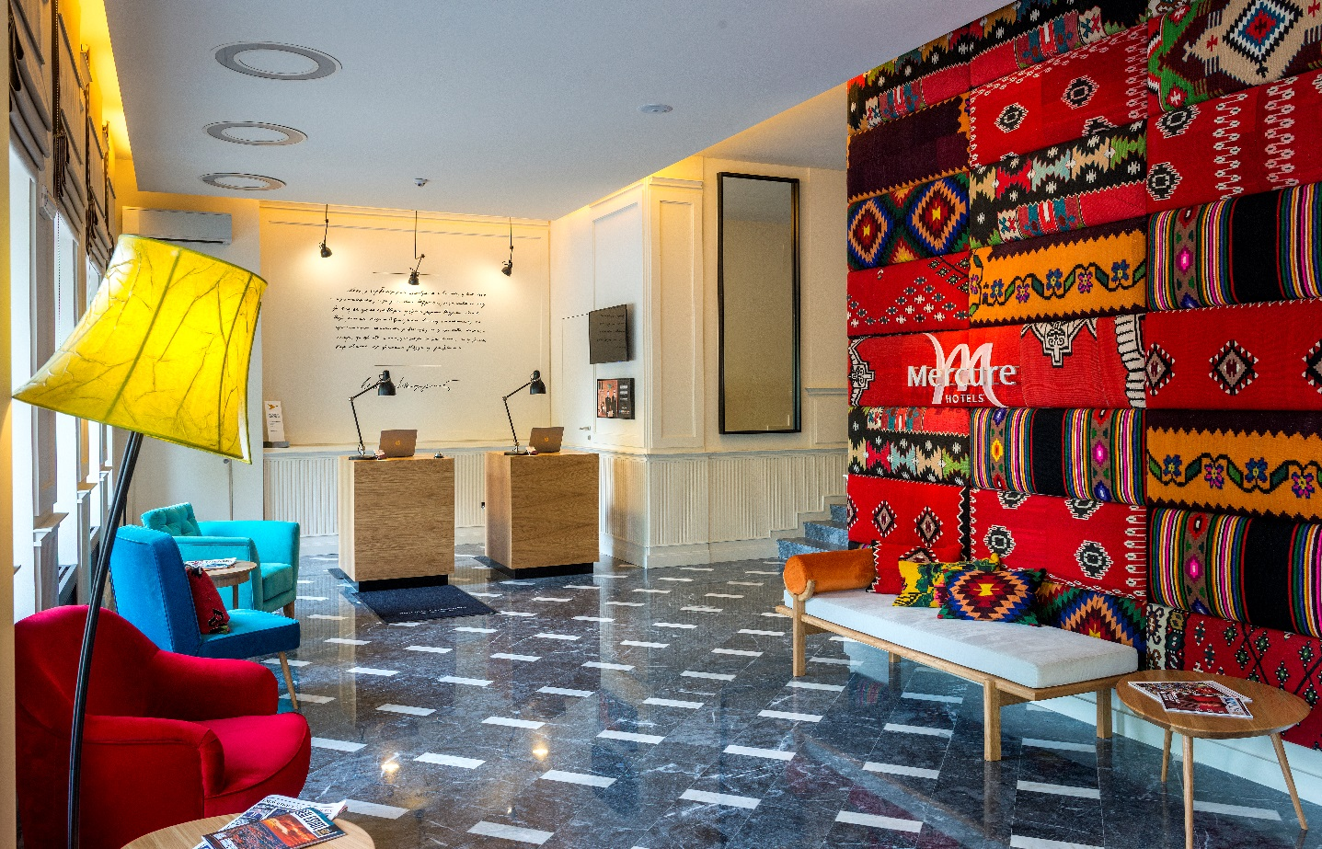

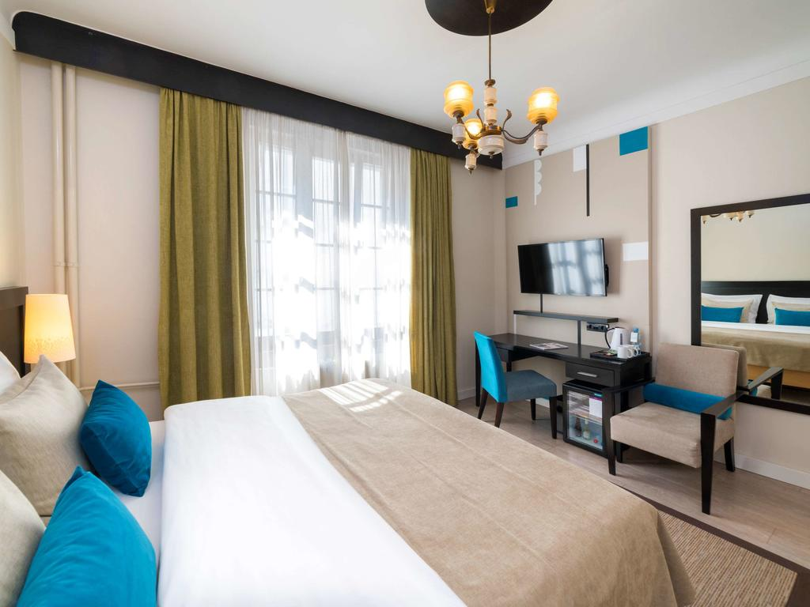 **Superior room** **Privilege room**

